|  |  |  |
| --- | --- | --- |
|  | | |
| **CAPSTONE PROJECT 1** | | |
| **Project Title: “English For You”** | | |
| **ARCHITECTURE DESIGN DOCUMENT** | | |
|  | **Code**  **Version**  **Date** | **:** E4U  **:**  1.0  **:**  27 - Sep - 2018 |
| **Warning Team**  **International School – Duy Tan University** | | |

|  |  |  |  |  |  |  |  |  |  |  |  |  |  |  |  |  |  |  |  |  |  |  |  |  |  |  |  |  |  |  |  |  |  |  |  |  |  |  |  |  |  |  |  |  |  |  |  |  |  |  |  |  |  |  |  |  |  |
| --- | --- | --- | --- | --- | --- | --- | --- | --- | --- | --- | --- | --- | --- | --- | --- | --- | --- | --- | --- | --- | --- | --- | --- | --- | --- | --- | --- | --- | --- | --- | --- | --- | --- | --- | --- | --- | --- | --- | --- | --- | --- | --- | --- | --- | --- | --- | --- | --- | --- | --- | --- | --- | --- | --- | --- | --- | --- |
| **Project Information**   |  |  |  |  |  |  | | --- | --- | --- | --- | --- | --- | | **Project acronym** | Eng4you | | | | | | **Project Tittle** | [E4U] English For You | | | | | | **Start Date** | Aug 15, 2018 | | **End Date** | | Dec 5, 2018 | | **Lead Institution** | International School, Duy Tan University | | | | | | **Project Mentor & contact details** | Mr. Vu Truong Tien  Email: vudalat@yahoo.com  Tel: 0914083188 | | | | | | **Scrum Master & contact details** | Nghia ,Tran Nguyen Huu  Email: trannguyenhuunghia97@gmail.com  Tel: 0934848229 | | | | | | **Team members** | **Name** | **Email** | | **Tel** | | | Truong, Do Van | [Truongdtct1230@gmail.com](mailto:Truongdtct1230@gmail.com) | | 01674275453 | | | Oanh, Doan Nu Thuc | [Doannuthucoanh0410@gmail.com](mailto:Doannuthucoanh0410@gmail.com) | | 01674552075 | | | Truc, Dinh Tran Anh | [Anhtruc2091997@gmail.com](mailto:Anhtruc2091997@gmail.com) | | 0947360347 | | |

|  |  |  |  |
| --- | --- | --- | --- |
| **DOCUMENT NAME** | | | |
| **Document Title** | Architecture Design Document | | |
| **Author(s)** |  | | |
| **Role** | Team Member, Scrum Master | | |
| **Date** | 24 – Sep – 2018 | **File name:** | ArchitectureDesign |
| **URL** |  | | |
| **Access** |  | | |

|  |  |  |  |
| --- | --- | --- | --- |
| **REVISION HISTORY** | | | |
| **Version** | **Person** | **Date** | **Description** |
| 1.0 | Team | 27-9-2018 |  |
| 1.1 |  |  |  |

|  |  |  |  |
| --- | --- | --- | --- |
| **Document Approval**  The following signatures are required for approval of this document | | | |
| **Mentor** | Mr.Truong Tien Vu | **Signature:** |  |
| **Date:** |  |
| **Scrum master** | Nguyen Tran Huu Nghia | **Signature:** |  |
| **Date:** |  |
| **Team member(s)** | Do Van Truong | **Signature:** |  |
| **Date:** |  |
| Dinh Tran Anh Truc | **Signature:** |  |
| **Date:** |  |
| Doan Nu Thuc Oanh | **Signature:** |  |
| **Date:** |  |

**CONTENTS**

**1.** **Introduction** 6

**1.1.** **Purpose** 6

**1.2.** **Documents Referenced** 6

**2.** **Project Statement** 6

**2.1.** **Project Overview** 6

**2.2.** **Business Driver** 6

**2.2.1.** **Business Problems** 6

**2.2.2.** **Business Need** 6

**2.3.** **Project Goals** 7

**3.** **Architecture Drivers** 8

**3.1.** **High-Level Requirements** 8

**3.2.** **System Context** 8

3.3. Architecture Driver Specification 8

3.4. Quality Attributes 12

**4.** **Constraints** 12

**4.1.** **Business Constraint** 12

**4.2.** **Technical Constraint** 12

**5.** **High level architecture** 13

**5.1.** **Component and Connector view (C&C view)** 13

**5.2.** **Module view** 14

**5.3.** **Allocation view** 15

1. **Introduction**
   1. **Purpose**

This specification covers following:

* Brief specification of the project, high level requirement, system context for the system.
* Use case diagram, detail quality attribution.
* Architecture presented by various architecture view types: Component and Connect tor view, Module view, Allocation view.
  1. **Documents Referenced**

***Table 1: Document Reference***

|  |  |
| --- | --- |
| **No** | **References** |
| **1** | ProductBacklog |
| **2** | ProjectPlan |

1. **Project Statement**
   1. **Project Overview**

* Project name: **English For You**
* Development team:

***Table 2: Development team***

|  |  |
| --- | --- |
| **Full name** | **Position** |
| Nguyen Tran Huu Nghia | Scrum Master |
| Do Van Truong | Team Member |
| Dinh Tran Anh Truc | Team Member |
| Doan Nu Thuc Oanh | Team Member |

* 1. **Business Driver**
     1. **Business Problems**
* English nowadays become second language
* Borings when learning English alone
* Lack of confidence in communication
* Need to much time to translate from native language to English
  + 1. **Business Need**
* Take initiative time to learning ( learning whenever they want)
* Communication with foreign to raise English skill
* Didn’t afraid when wrong
* An website can learning English and entertainment
* Interactive, co-operate with other people to learning English
  1. **Project Goals**

The goal of project is to build the English for you [E4U] website with four main functions.

* ***Game words explain:*** The website will auto matching two people in one team in order to explain words and another will guess what that word is.
* ***Game Listen:*** The website will choose a little piece of a random song for user hear and correct lyric of that song.
* ***Chat with foreign:*** The website will list the users are online and user can choose the one you want to chat to.

- ***Translate:*** The website can help user translate when user click right mouse on that word.

1. **Architecture Drivers**
   1. **High-Level Requirements**

Refer to E4U_ProductBacklog_Ver.1.0

* 1. **System Context**

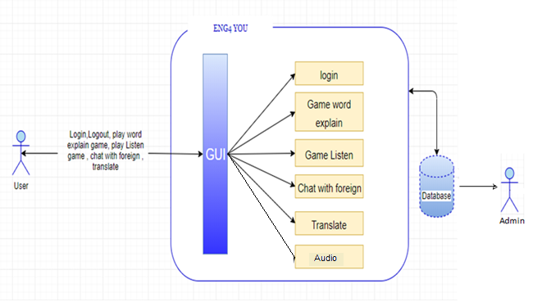

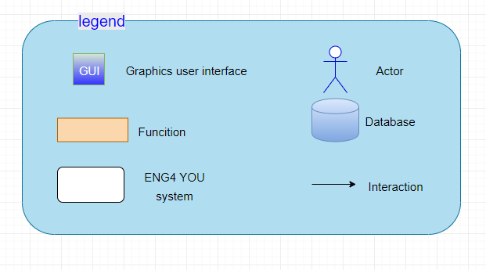

***Figure 1: Context diagram***

## Architecture Driver Specification

***Use Case Entities***

|  |  |
| --- | --- |
| ID | E01 |
| Title | Admin |
| Description | Admin who is the system administrator |
| Provides Assumptions | Admin is the management of all posts, accounts of system |
| Requires Assumptions | Already have an account |
| Identified Use Cases | UC02: Login, UC03: Logout, UC04: Change passwords, UC05: Delete accounts |

|  |  |
| --- | --- |
| ID | E01 |
| Title | Users |
| Description | Users who are using system and interact with website |
| Provides Assumptions | Provide person information, manage their posts |
| Requires Assumptions | Already have an account |
| Identified Use Cases | UC01: Register, UC02: Login, UC03: Logout, UC04: Change password , UC05: Remember Password, UC06: Chat form, UC07: Connect with other players |

***Operational Use Cases***

|  |  |
| --- | --- |
| ID | UC01 |
| Title | Register |
| Description | This is a register page for new user. |
| Entities Involved | E02: Users |
| Preconditions | Internet connection |
| Primary Flow | 1. Users access to address of “English For You” website  2. Users sign in account and input, full name, password, gender, address, phone, email, and then click on [Register] button.  3. Account is successfully created when inputting correctly value on fields. |
| Postconditions | Internet connection |
| Alternate Flows | - In step 1 of the Primary Flow, if the user can’t connect internet: the system shows the error message and requires the internet connection.  - In step 2 of the Primary Flow, if one of fields is invalid then the system shows the error message.  - In step 3 of the Primary Flow, generate failure or success messages when processing. |

|  |  |
| --- | --- |
| ID | UC02 |
| Title | Login |
| Description | Click on Login to access into system by their account |
| Entities Involved | E01: Admin, E02: Users |
| Preconditions | Internet connection |
| Primary Flow | 1. User clicks [Login] button on Bar menu to open login form.  2. User inputs data value on [Email or PhoneNumber] textbox and [Password] textbox.  3. User clicks on [Login] button.  4. System validates [Email or PhoneNumber] and password.  5. User visits on Home Page. |
| Postconditions |  |
| Alternate Flows | - In step 4 of the Primary Flow, if [Email or PhoneNumber] or password is incorrect.  1. The system will prompt user “input wrong email, phone number or password”.  2. User clicks ok to continue.  If [Email or PhoneNumber] and password are correct, continue to step 5. |

|  |  |
| --- | --- |
| ID | UC03 |
| Title | Logout |
| Description | Click on Logout to exit website |
| Entities Involved | E01: Admin, E02: User |
| Preconditions | Successfully logged in the website |
| Primary Flow | 1. User clicks [Logout] button on [Account Settings] menu bar.  2. System checks and closes account. Return Home Page. |
| Postconditions |  |
| Alternate Flows | In step 2 of the Primary Flow, if the system have a problem,it will show error messages. |

|  |  |
| --- | --- |
| ID | UC04 |
| Title | Change password |
| Description | Click on change password on menu of website |
| Entities Involved | E01: Admin, E02: User |
| Preconditions | Successfully logged in the website |
| Primary Flow | 1. User clicks [Change Password] button on [Account Settings] menu  bar.  2. System checks and returns Change Password Page.  3. User inputs into [Old Password], [New password], and [Repeat New Password] field.  4. Click [Save Change] button. |
| ID | UC05 |
| Title | Remember password |
| Description | Select the rating star for the post |
| Entities Involved | E01: Admin, E02: User |
| Preconditions | Click on remember password on menu of website |
| Primary Flow | 1.Users can remember password when Users input password on [Password] field and click on [Remember Password] button.  2.Show the error messages when password is wrong. |
| Postconditions |  |
| Alternate Flows |  |

|  |  |
| --- | --- |
| ID | UC06 |
| Title | Delete accounts |
| Description | Admin deletes the accounts breaking the Term of website |
| Entities Involved | E01: Admin |
| Preconditions | Successfully logged in the website as an admin |
| Primary Flow | 1. Admin clicks on [List of break the Term].  2. System checks and returns the list of account with information such as: name of account, the times break the Terms of use.  3. Admin clicks on [Delete] an account in this list.  4. System show messages “Do you want to delete this account? Yes or No”  4.1 If Users want to delete, user clicks “Yes” button in the message.  4.2 If Users don’t want to delete, click “No” in the message of the FSR Website |
| Postconditions |  |
| Alternate Flows |  |

|  |  |
| --- | --- |
| ID | UC07 |
| Title | Chat form |
| Description | Select the rating star for the post |
| Entities Involved | E02: Users |
| Preconditions | Successfully logged in the website |
| Primary Flow | 1. Users click on Enter the words you want to explain or reply to the chat box.  2.Click the [Chat]. |
| Postconditions |  |
| Alternate Flows |  |

|  |  |
| --- | --- |
| ID | UC08 |
| Title | Words Explain |
| Description | Select the rating star for the post |
| Entities Involved | E02: Users |
| Preconditions | Successfully logged in the website |
| Primary Flow | 1.Users to the game Explain Word.  2.Click the [Play].  3.Wait other player.  4.If User don’t want to connect anymore, User can click [Cancel]. |
| Postconditions |  |
| Alternate Flows |  |

## Quality Attributes

***Table 3: Quality Attribute: Usability***

|  |  |
| --- | --- |
| **Quality attributes: Usability** | **ID:** QA01 |
| **Stimulus** |  |
| **Source(s) of the stimulus** | User |
| **Relevant environment** | Runtime |
| **Architectural elements** | Website |
| **System response** |  |
| **Response measure(s)** |  |

1. **Constraints**
   1. **Business Constraint**

* Project will be started on: 15 – Aug – 2018
* Project will be finished on: 05 – Dec – 2018
* Project will be finished in 119 days (812 hours).
  1. **Technical Constraint**
* Technical for Development

Technology: C#, .NET, JavaScript Languages.

* Environment:
  + Operating system: Computer OS, any device used Web Browser.
  + Develop tools: Visual Studio.
  + Source version control: Git.
  + Database: Microsoft SQL Server 2016.
  + Internet Connection.

1. **High level architecture**
   1. **Component and Connector view (C&C view)**

The diagram below shows the overview architecture including component and other related component. We have representations and behaviors for important components in the following sections.

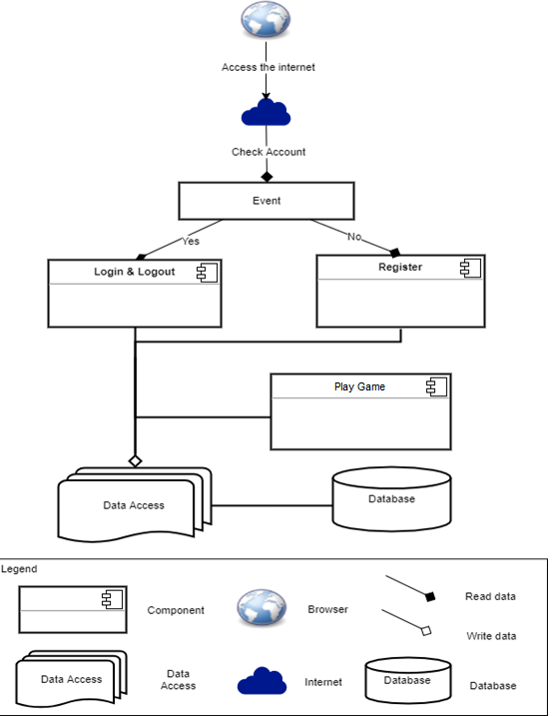

***Figure 2: C&C view***

* **Prose:**
  + User will use web browser and requires internet connection to access to system. One user accessed to system, the front-end interface will be displayed. With these front-end interfaces, user can go around the entire of the website. They can know which functions are on system easily. They will have a panoramic picture of some of the main functions of the system. From that, database from server can be transacted to users by back-end working.
  + The website is authorized to access the database through data access.
  1. **Module view**

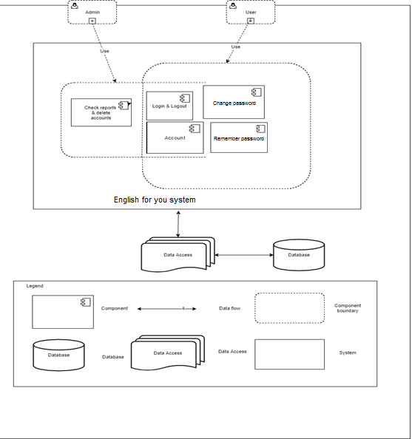

***Figure 3: Module view***

* **Prose:**

These modules have relationship and interact each other to create this system, module Login determines the functionality of users, after logging in successfully, it will be directed to the modules that users have permission to access. The functionality interacting each other, relationship will be defined by arrows.

* 1. **Allocation view**

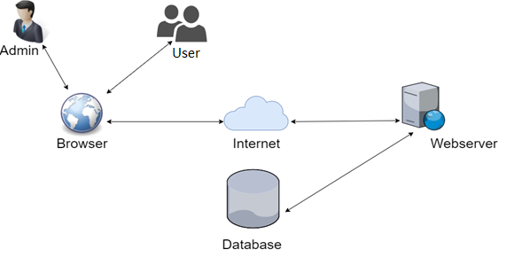

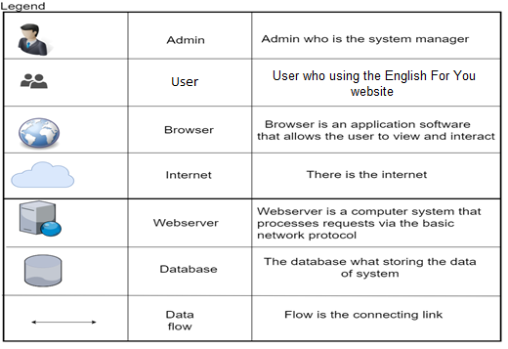

***Figure 4: Allocation view***

* **Prose:**

User will use web browser (Chrome, Firefox, Opera, Safari, ...) to can access to the system. It required have internet network if you use external link. Once you did access to the website, the Asp.net environment will be processed handle to interact database between user and system. Any transaction between user and system will be implemented on Firebase.